Lab 3- DIFFERENT BODIES

Name
Address
Email
Website
Mobile phone
- Please write a short (max 250 word) biography about you and your work. If selected this will be used for our website page about you so we are interested in who you are as an artist rather than a cv list of productions.

- Please tell us about your interest and experience in making theatre or dance for young audiences giving examples of work/projects you have been involved with and what your role in the process was.

- Tell us about why you want to explore the topic of ‘Different Bodies’. What interests you about it and what specific questions or areas of research inspire you artistically and personally?

- Please tell us why you would like to take part in the Lab and what impact you hope it might have on your practice:

If you have chosen filmed/audio answers to Questions 1 - 3 only**:

Website link and password for your film –

To apply:
First of all, read the accompanying Guidelines so you know what we are looking for. Please email this application form with a good quality photograph of yourself* (this will also be used on the project website if you are selected for the Lab) to pernille@aabendans.dk by the deadline of March 6 2020. Make sure your application form is saved wtih your full name in the title and that your email has PUSH+Different Bodies Lab as the subject title.

*Your photograph should be sent as a jpeg file, at least 300DPI in quality and 2MB in size and should be landscape.

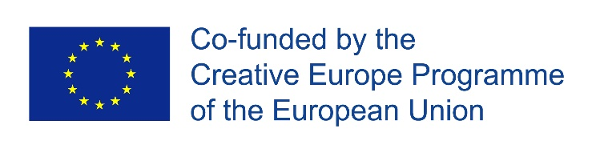
**Filmed answers should be uploaded to Vimeo or Youtube as a password protected link.

